MOTORSPORT IRELAND KART RACE EVENT SUPPLEMENTARY REGULATIONS
Venue:Athboy Karting Athboy Co Meath
Organising Club: Westmeath and District Motor Club
Permit No: 26/098 Date: 26th July 2026 1Governance:
The event will be run under the General Competition Rules of Motorsport Ireland (incorporating the provisions of the International Sporting Code of the FIA), Appendix 70.1, 70.2, 70.3, 70.4 & 70.5 of the current Motorsport Ireland Yearbook, these Supplementary Regulations and any other instructions published by Motorsport Ireland or the Organising Club relating to the event.
- - Officials:
Clerk of the Course : Jonathan Quigley
Deputy Clerk of the Course: Vinny Hayes
Motorsport Ireland Stewards: Jim Reilly / Brian Morris
Club Steward: John Corrigan
Chief Scrutineer: Pat O`Dowd
Chief Timekeeper: Paul Grogan
Children’s Officer: Ernest Alford
Judges of fact: Will be named in final instructions or in a bulletin on the morning of the event which will be published at the venue and on the digital notice board.

- - Entries:
All entrants must hold a valid Motorsport Ireland Minor Entrants Licence or Motorsport UK PG Entrants licence.
Any competitor who is under 18-years old must have their parent/legal guardian hold a Minor Entrant licence. This is applied for by the parent/legal guardian. This person must be present at check in at all events the under-18-year-old wishes to compete in and remain for the duration of the event and publication of results. Alternatively they may nominate a third party to act as entrant as outlined below and in GCR 108.2.3.
For those wishing a third-party (anyone who is not a parent/legal guardian) to fulfil this role, then Garda Vetting is required. You will be asked to upload a paper copy of the Garda Vetting form when applying for this licence online.
If the holder of the Minor Entrant Licence is not the parent / legal guardian of the minor then a duly completed Minor Entrant nomination form must be presented at licence check (available at https://motorsportireland.com/Public/Public/Competitors/Competitor-forms.aspx )
4 – Classes & Entry Fees:
Classes and entry fees will be as follows:
ROTAX Micro Max & Mini Max = €145.00
ROTAX Junior Max = €175.00
ROTAX Senior Max & Senior Max 177 = €185.00
IAME Cadet = €145.00
IAME X30 Junior = €175.00
IAME X30 Senior = €185.00
Entries will be completed using the INEO system and only Registered drivers will be permitted to enter an Event. Entries will close at 23:59 on Sunday the 19th July in advance of the Event as per the Sporting Regulations. Transponder Numbers must be complete and accurate on the entry form. If you do not have a transponder they can be booked from
https://www.timing.ie/transponder-rental/motorsport-ireland-karting-championship-annualtransponder-rental/
No late entries will be accepted under any circumstances
Refunds will only be given if your entry is officially withdrawn by email on or before 4pm Friday the 24th of July 2026. An administration fee of €20.00 will apply to any refunds.
The event organisers reserve the right to refuse an entry without providing a reason.
- - Surveillance:
Audio and visual surveillance will be in operation through the event.
- - Designated Fuel Station:
It will be each competitor’s responsibility to purchase their own petrol from free practice until completion of the Event. Competitors must purchase fuel from the official designated fuel station. It will also be the responsibility of each competitor to ensure they purchase their Fuel from the correct pump or pumps at the designated station. These will be listed in the Final instructions for the Event.
It is forbidden to add any liquid and/or power-boosting chemicals to the fuel.
- - Abuse issues:
Any incidents of abuse will be reported to the Clerk of the Course who will deal with the matter and may refer the matter to the stewards.

- - Starting of Engines:
Karts on stands in the assembly area or dummy grid area must NOT have engines running at any time. Karts may only be started on the dummy grid when the kart has all four wheels on the ground and the driver is sitting in the Kart.
No lifting of a Kart with the engine running is permitted on the dummy grid.
- - Technical Regulations:
Technical Regulations for all classes will be as defined in the 2026 Motorsport Ireland regulations published for each class on the Motorsport Ireland Website. The technical regulations will be as per technical regulations 70.2, all the necessary Homologations Fiches for the racing classes.
https://www.motorsportireland.com/s/Appendix-702-Kart-General-Technical-Regulations.pdf 10 - Sporting Regulations:
The sporting regulations for the Event will be as per 70.1 as available on the Motorsport Ireland website.
https://www.motorsportireland.com/s/Appendix-701-Kart-Sporting-Regulations.pdf 11 - Results:
Results will be published for Timed Qualifying, & all races in Timing.ie for the Event. https://timing.ie/mikarting 12 - Drivers Briefing:
Attendance at Drivers Briefing will take place at 08:30 on the dummy grid. Attendance is compulsory for all drivers, a role call will be taken. For all Drivers under the Age of 18 it is required that their Entrant also attends Driver’s briefing.
- - Event Check In:
Will take place on Saturday the 25th between 2:00 and 4:30 pm in the clubhouse. It will be the responsibility of each driver to ensure their sign on, scrutiny and tyre registration is completed using the INEO system in advance of all Events. Each Driver must present with their digital or physical race licence and/or ID and also have their suit and helmet ready for inspection.
If anyone is unable to attend on Saturday, they MUST contact the Club via email
(wmdmc.22@gmail.com) and make arrangements for their check in to be completed on Sunday Morning. This will only be accommodated by arrangement with no exceptions.

- - Tyres:
As Per Class Regulations

- - Flag Signals, Light, LED Panel:

The officials of the meeting will have the ability to display messages to competitors whilst on track through the use of an LED panel mounted on or near the Start line Gantry. Messages displayed to competitors on the LED panel will have the same meaning and effect as that of flags and number boards and must be obeyed at all times. Failure to do so may result in a penalty. Below are samples only of messages which may be displayed:

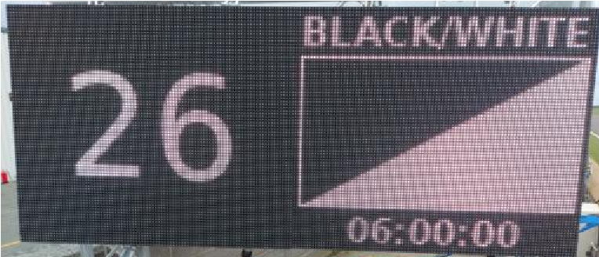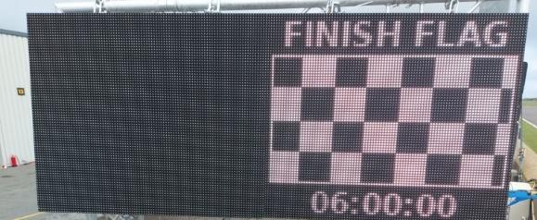

Flag signals may be supplemented by or replaced by light signals and will have the same authority and jurisdiction as flag signals. Therefore, breaches of signals given by light signals will be treated in the same way as breaches of flag signals.

